Lytham Church of England Primary School PSHE Overview
British Values Golden Threads  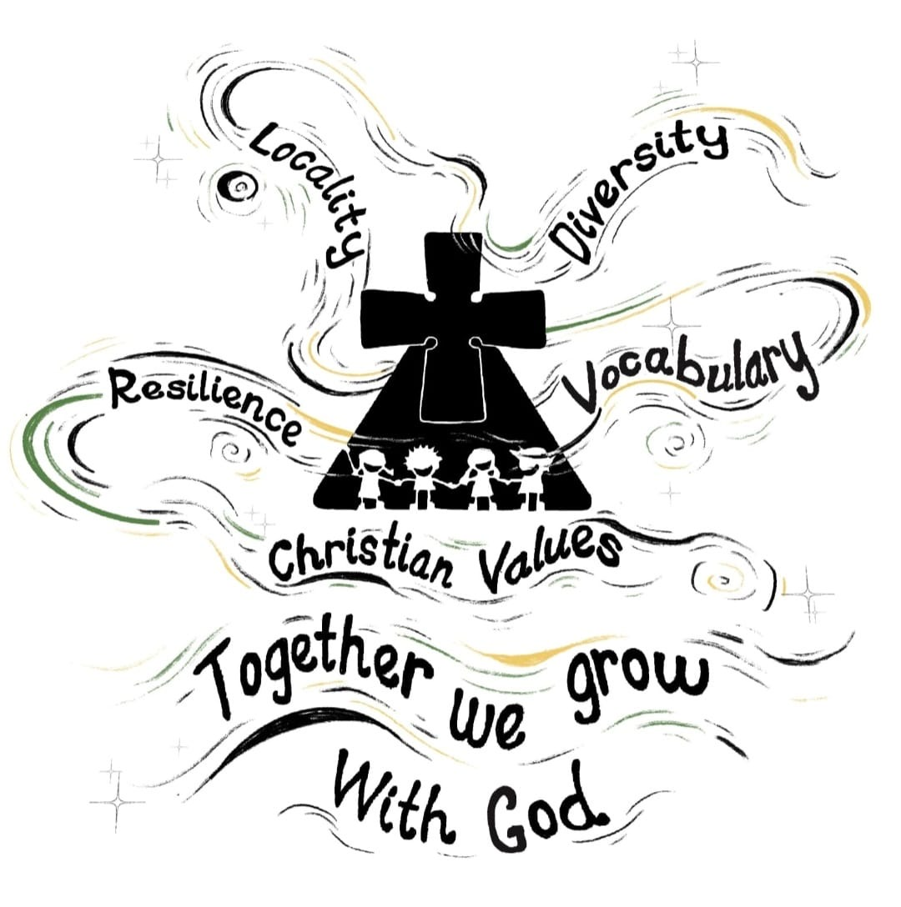 | Democracy Rule of Law Respect Tolerance Individual Liberty  At Lytham C of E Primary our SCARF PSHE curriculum will be supporting this valuable area of children's learning, enabling them to make appropriate choices as they navigate the rich, varied, often complex and ever-evolving life in modern Britain - and the world. The British values run throughout our PSHE curriculum and most of them feature within each unit, however the focus areas are listed within the units below.  Christian Values Locality Diversity Vocabulary Resilience  Our Golden Threads weave through all our teaching and learning and are central in the development and delivery of our PSHE curriculum
 | Autumn 1 | Autumn 2 | Spring 1 | Spring 2 | Summer 1 | Summer 2
Nursery | Me and My Relationships  Marvellous Me  I’m Special  People who are special to me  Rule of Law  Respect  Tolerance  Individual Liberty  Friendship  Love  Diversity  Locality  Vocabulary | Being My Best  What does my body need?  I can keep trying  I can do it!  Tolerance  Respect  Individual Liberty  Determination  Resilience  Vocabulary | Keeping Safe  People who help me and keep me safe  Safety indoors and outdoors  What is safe to go into my body  Democracy  Rule of Law  Respect  Tolerance  Individual Liberty  Respect  Locality  Diversity  Vocabulary | Rights and Respect  Looking after myself  Looking after others  Looking after my environment  Democracy  Rule of Law  Respect  Tolerance  Individual Liberty  Friendship  Service  Locality  Diversity  Vocabulary  Resilience | Growing and Changing  Growing and changing in nature  When I was a baby  Girls, boys and families  Respect  Tolerance  Individual Liberty  Love  Locality  Diversity  Vocabulary | Valuing Difference  Friends and Family  Me and My Friends  Including everyone  Respect  Tolerance Individual Liberty  Friendship  Love  Respect  Diversity  Vocabulary
Reception | Me and My Relationships  All about Me  What makes me special  Me and my special people  Who can help me?  My feelings  Rule of Law  Respect  Tolerance  Individual Liberty  Friendship  Thankfulness  Respect  Locality  Diversity  Vocabulary  Resilience | Valuing Difference  I’m special, you’re special  Same and different  Same and different families  Same and different homes  I am caring  I am a friend  Respect  Tolerance  Individual Liberty  Friendship  Thankfulness  Love  Locality  Diversity  Vocabulary  Resilience | Being My Best  Yes I can!  Bouncing back when things go wrong  My healthy mind  Healthy eating  A good night’s sleep  Move your body  Democracy  Respect  Tolerance  Individual liberty  Determination  Forgiveness  Diversity  Vocabulary  Resilience | Keeping Safe  What’s safe to go onto my body  What’s safe to go into my body (including medicines)  Safe indoors and outdoors  Listening to my feelings  People who help to keep me safe  Democracy  Rule of Law  Respect  Tolerance  Individual Liberty  Respect  Service  Locality  Vocabulary  Resilience | Growing and Changing  Life stages – plants, animals, humans  Life stages – Human life stage – who will I be?  Where do babies come from?  Getting bigger  Me and my body – girls and boys  Respect  Tolerance  Individual Liberty  Friendship  Locality  Diversity  Vocabulary  Resilience | Rights and Respect  Looking after my special people  Looking after my friends  Caring for our world  Being helpful at home and caring for our classroom  Looking after money (1) – recognising, spending, using  Looking after money (2) – saving money and keeping it safe  Democracy  Rule of Law  Respect  Individual Liberty  Friendship  Love  Respect  Service  Locality  Diversity  Vocabulary  Resilience
Year 1 | Me and My Relationships  Why do we have classroom rules/  How are you listening?  Thinking about feelings  Our feelings  Good friends  Democracy  Rule of Law  Respect  Tolerance  Individual Liberty  Friendship  Thankfulness  Honesty  Thankfulness  Diversity  Vocabulary  Resilience | Being My Best  Eat well  I can eat a rainbow  Catch it! Bin it! Kill it!  Harold learns to ride his bike  Pass on the praise  Harold’s wash and brush up  Inside my wonderful body!  Rule of Law  Respect  Tolerance  Individual Liberty  Determination  Locality  Diversity  Vocabulary  Resilience | Valuing Difference  Harold’s school rules  Same or different?  Unkind, tease or bully?  It is not fair  Who are our special people?  Our special people balloons  Respect  Tolerance  Individual Liberty  Friendship  Forgiveness  Locality  Diversity  Vocabulary  Resilience | Keeping Safe  Who can help?  Good or bad touches?  Sharing pictures?  What could Harold do?  Harold loses Geoffrey  Democracy  Rule of Law  Respect  Friendship  Honesty  Faith  Locality  Vocabulary  Resilience | Growing and Changing  Healthy Me  Who can help?  Surprises and secrets  Keeping privates private  Then and now  Taking care of a baby  Rule of Law  Respect  Individual Liberty  Love  Respect  Honesty  Vocabulary  Resilience | Rights and Respect  Harold has a bad day  Around and about the school  Taking care of something  Basic first aid  How should we look after our money?  Democracy  Rule of Law  Respect  Faith  Service  Diversity  Vocabulary  Resilience
Year 2 | Me and My Relationships  Our ideal classroom  How are you feeling today?  Let’s all be happy!  Being a good friend  Types of bullying  Don’t do that!  Bullying or teasing?  Democracy  Rule of Law  Respect  Tolerance  Friendship  Thankfulness  Respect  Diversity  Vocabulary  Resilience | Valuing Difference  What makes us who we are?  My special people  How do we make others feel?  When someone is feeling left out  An act of kindness  Solve the problem  Democracy  Respect  Tolerance  Individual Liberty  Friendship  Love  Faith  Respect  Diversity  Vocabulary  Resilience | Rights and respect  Getting on with others  When I feel like erupting  Feeling safe  Playing games  Harold saves for something special  How can we look after our environment?  Democracy  Respect  Tolerance  Individual Liberty  Friendship  Respect  Locality  Diversity  Vocabulary  Resilience | Being My Best  You can do it!  My day  Harolds postcard – helping us to keep clean and healthy  Basic first aid  Harold’s bathroom  What does my body do?  Democracy  Respect  Individual Liberty  Determination  Thankfulness  Respect  Vocabulary  Resilience | Growing and Changing  A helping hand  Sam moves away  Haven’t you grown!  My body, your body  Some secrets should never be kept  Respecting privacy  Rule of Law  Respect  Tolerance  Individual Liberty  Honesty  Respect  Locality  Vocabulary  Resilience | Keeping Safe  Harold’s picnic  How safe would you feel?  What should Harold say?  I don’t like that!  Should I tell?  Fun or not?  Democracy  Rule of Law  Respect  Honesty  Faith  Vocabulary  Resilience
Year 3 | Me and My Relationships  As a rule  Looking after our special people  How can we solve this problem?  Telegram team challenge  Friends are special  Thunks  Dan’s dare  Democracy  Rule of Law  Respect  Tolerance  Individual Liberty  Friendship  Thankfulness  Honesty  Diversity  Vocabulary  Resilience | Keeping Safe  Danger or risk?  The Risk robot  Super Searcher  Help or harm?  Alcohol and cigarettes: the facts  Raisin challenge  Rule of Law  Individual Liberty  Honesty  Locality  Vocabulary  Resilience | Valuing Difference  Respect and challenge  Family and friends  My community  Our friends and neighbours  Let’s celebrate our differences  Zeb  Respect  Tolerance  Individual Liberty  Friendship  Love  Respect  Locality  Diversity  Vocabulary  Resilience | Rights and Respect  Helping each other to stay safe  Harold’s environment project  Our helpful volunteers  Let’s have a tidy up!  Can Harold afford it?  Democracy  Rule of Law  Respect  Individual Liberty  Friendship  Respect  Locality  Diversity  Resilience | Growing and Changing  Relationship tree  Body space  None of your business!  Secret or surprise?  My changing body  Basic first aid  Rule of Law  Respect Individual Liberty  Friendship  Respect  Vocabulary  Resilience | Being My Best  Derek cooks dinner (healthy eating)  Poorly Harold  For or against?  Body team work  I am fantastic!  Respect  Tolerance  Individual Liberty  Service  Love  Locality  Diversity  Vocabulary  Resilience
Year 4 | Me and My Relationships  Different feelings  Ok or not ok?  An email from Harold  Under pressure  Human machines  Democracy  Respect  Tolerance  Individual Liberty  Friendship  Honesty  Diversity  Vocabulary  Resilience | Keeping Safe  Danger, risk or hazard?  How dare you!  Keeping ourselves safe  Medicines: check the label  Raisin challenge  Traffic lights  Know the norms  Democracy  Rule of law  Friendship  Faith  Locality  Vocabulary  Resilience | Being My Best  What makes me ME!  Making choices  SCARF hotel  Harold’s seven R’s  Basic first aid  My school community  Democracy  Rule of Law  Respect  Individual Liberty  Friendship  Love  respect  Locality  Diversity  Vocabulary  Resilience | Rights and Respect  Who helps us stay healthy and safe?  It’s your right  How do we to make a difference?  In the news!  Safety in numbers  Democracy  Rule of Law  Respect  Friendship  Respect  Service  Locality  Diversity  Vocabulary  Resilience | Growing and Changing  My feelings are all over the place!  All change!  Preparing for changes at puberty  Secret or surprises?  Together  Moving house  Rule of Law  Respect  Tolerance  Faith  Locality  Diversity  Vocabulary  Resilience | Valuing Difference  Can you sort it?  The people we share our world with  That is such a stereotype!  Islands  Friend or acquaintance?  Democracy  Respect  Tolerance  Individual Liberty  Friendship  Love  Respect  Honesty  Locality  Diversity  Vocabulary  Resilience
Year 5 | Me and My Relationships  Give and take  How good a friend are you?  Our emotional needs  Being assertive  Communication  Collaboration challenge!  Democracy  Rule of Law  Respect  Tolerance  Individual Liberty  Friendship  Service  Honesty  Locality  Diversity  Vocabulary  Resilience | Valuing Difference  Qualities of friendships  Kind conversations  Is it true?  The land of the Red People  Stop, start stereotypes  It could happen to anyone  Happy being me  Democracy  Respect  Tolerance  Individual Liberty  Friendship  Love  Service  Honesty  Locality  Diversity  Vocabulary  Resilience | Rights and Respect  What’s the story?  Fact or opinion?  Mo makes a difference  Rights, respect and duties  Spending wisely  Lend us a fiver!  Democracy  Rule of Law  Respect  Respect  Honesty  Vocabulary  Resilience | Being My Best  It all adds up!  Different skills  My school community  Basic first aid including Sepsis Awareness  Independence and responsibility  Star qualities?  Rule of Law  Respect  Individual Liberty  Friendship  Determination  Locality  Diversity  Vocabulary  Resilience | Growing and Changing  How are they feeling?  Taking notice of our feelings  Growing up and changing bodies  Changing bodies and feelings  Help I’m a teenager – get me out of here!  Rule of Law  Respect  Individual Liberty  Friendship  Love  Respect  Diversity  Vocabulary  Resilience | Keeping Safe  Spot bullying  Play, like, share  Would you risk it?  Vaping: healthy or unhealthy?  Decision dilemmas  Democracy  Rule of Law  Individual Liberty  Friendship  Love  Faith  Honesty  Locality  Diversity  Vocabulary  Resilience
Year 6 | Me and My Relationships  Working together  Let’s negotiate  Solve the friendship problem  Behave yourself  Assertiveness skills  Don’t force me  Acting Appropriately  Democracy  Rule of Law  Respect  Tolerance  Individual Liberty  Friendship  Locality  Diversity  Vocabulary  Resilience | Valuing Difference  OK to be different  We have more in common than not  Respecting differences  Tolerance and respect for others  Boys will be boys? – challenging gender stereotypes  Advertising friendships!  Democracy  Respect  Tolerance  Friendship  Locality  Diversity  Vocabulary  Resilience | Being My Best  This will be your life!  Our recommendations  What’s the risk?  Basic first aid including sepsis awareness  Five Ways to Wellbeing project  Respect  Tolerance  Individual Liberty  Friendship  Locality  Diversity  Vocabulary  Resilience | Rights and Respect  Two sides to every story  Fakebook friends  Democracy in Britain 1 – Elections  What’s it worth?  Democracy  Rule of Law  Individual Liberty  Friendship  Locality  Diversity  Vocabulary  Resilience | Keeping Safe  Think before you click!  To share or not to share?  What sort of drug is….?  Drugs: it’s the law!  Alcohol: what is normal?  Rule of Law  Individual Liberty  Friendship  Locality  Diversity  Vocabulary  Resilience | Growing and Changing  I look great!  Media manipulation  Pressure online  Is this normal?  Making babies  Democracy  Rule of Law  Respect  Tolerance  Individual Liberty  Friendship  Locality  Diversity  Vocabulary  Resilience

