22
Lytham Church of England Primary School

Design and Technology Policy

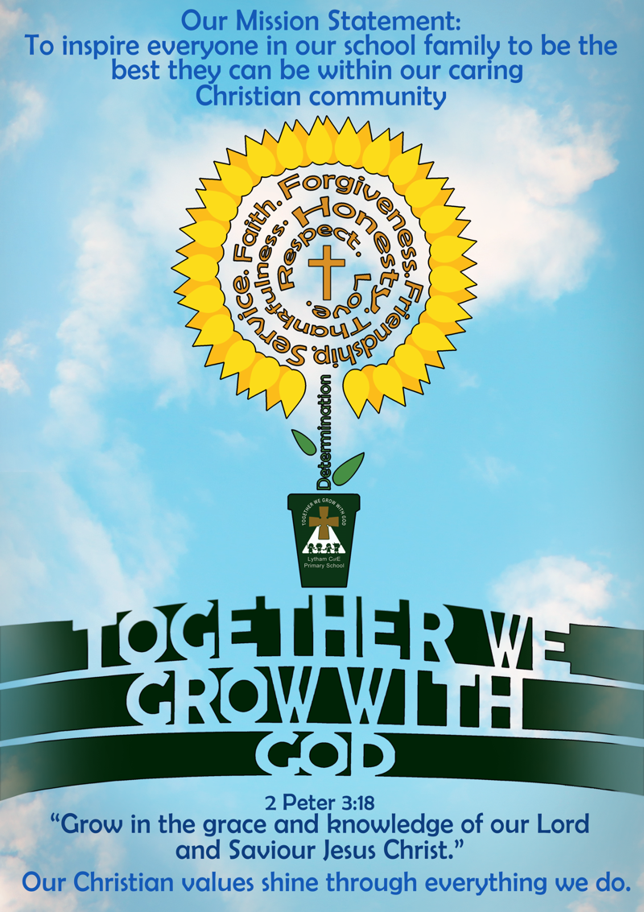

Subject Leader: Angela Lumby
Linked Governor: Marianne Cottier-Brown
Date of Policy: June 2026
Date of Review: June 2027

Together We Grow with God
Mission Statement
To inspire everyone in our school family to be the best they can be within our caring Christian community.
1. Curriculum Statement
Intent
Lytham C of E uses Kapow Primary's Design and technology scheme of work from Reception to Year 6, which aims to inspire pupils to be innovative and creative thinkers who have an appreciation for the product design cycle through design, creation, and evaluation. Our Nursery children use Development Matters as the basis for their Design and Technology learning. We want pupils to develop the confidence to take risks, through drafting design concepts, modelling, and testing and to be reflective learners who evaluate their work and the work of others. Through our scheme of work, we aim to build an awareness of the impact of design and technology on our lives and encourage pupils to become resourceful, enterprising citizens who will have the skills to contribute to future design advancements. Kapow Primary's Design and technology scheme of work enables pupils to meet the end of key stage attainment targets in the national curriculum and the aims also align with those in the national curriculum.
Implementation
The Design and technology national curriculum outlines the three main stages of the design process: design, make and evaluate. Each stage of the design process is underpinned by technical knowledge which encompasses the contextual, historical, and technical understanding required for each strand. Cooking and nutrition has a separate section, with a focus on specific principles, skills and techniques in food, including where food comes from, diet and seasonality.
The National curriculum organises the Design and technology attainment targets under five
subheadings or strands:
- Design
- Make
- Evaluate
- Technical knowledge
- Cooking and nutrition

Kapow Primary's Design and technology scheme has a clear progression of skills and knowledge within these five strands across each year group. Our Progression of skills document shows the skills that are taught within each year group and how these skills develop to ensure that attainment targets are securely met by the end of each key stage.
Through Kapow Primary's Design and technology scheme, pupils respond to design briefs and scenarios that require consideration of the needs of others, developing their skills in six key areas:
- Mechanisms
- Structures
- Textiles
- Cooking and nutrition (Food)
- Electrical systems KS2) and
- Digital world (KS2)
Each of our key areas follows the design process (design, make and evaluate) and has a particular theme and focus from the technical knowledge or cooking and nutrition section of the curriculum. The Kapow Primary scheme is a spiral curriculum, with key areas revisited again and again with increasing complexity, allowing pupils to revisit and build on their previous learning.
Lessons incorporate a range of teaching strategies from independent tasks, paired and group work including practical hands-on, computer-based and inventive tasks. This variety means that lessons are engaging and appeal to those with a variety of learning styles. Differentiated guidance is available for every lesson to ensure that lessons can be accessed by all pupils and opportunities to stretch pupils' learning are available when required. Strong subject knowledge is vital for staff to be able to deliver a highly effective and robust Design and technology curriculum. Each unit of lessons includes multiple teacher videos to develop subject knowledge and support ongoing CPD. Kapow has been created with the understanding that many teachers do not feel confident delivering the full Design and technology curriculum and every effort has been made to ensure that they feel supported to deliver lessons of a high standard that ensure pupil progression.

Impact
The impact of Kapow Primary's scheme can be constantly monitored through both formative and summative assessment opportunities. Each lesson includes guidance to support teachers in assessing pupils against the learning objectives. Furthermore, each unit has a unit quiz and knowledge catcher which can be used at the start and/ or end of the unit. After the implementation of Kapow Primary Design and technology, pupils should leave school equipped with a range of skills to enable them to succeed in their secondary education and be innovative and resourceful members of society. The expected impact of following the Kapow Primary Design and technology scheme of work is that children will:
- Understand the functional and aesthetic properties of a range of materials and resources.
- Understand how to use and combine tools to carry out different processes for shaping, decorating, and manufacturing products.
- Build and apply a repertoire of skills, knowledge and understanding to produce high quality, innovative outcomes, including models, prototypes, CAD, and products to fulfil the needs of users, clients, and scenarios.
- Understand and apply the principles of healthy eating, diets, and recipes, including key processes, food groups and cooking equipment.
- Have an appreciation for key individuals, inventions, and events in history and of today that impact our world.
- Recognise where our decisions can impact the wider world in terms of community, social and environmental issues.
- Self-evaluate and reflect on learning at different stages and identify areas to improve.
- Meet the end of key stage expectations outlined in the National curriculum for Design and technology.
- Meet the end of key stage expectations outlined in the National curriculum for Computing

2. Teaching and Learning
Our Kapow Primary scheme of work fulfils the statutory requirements outlined in the national curriculum (2014). The national curriculum Programme of study for Design and technology aims to ensure that all pupils:
- develop the creative, technical and practical expertise needed to perform everyday tasks confidently and to participate successfully in an increasingly technological world.
- build and apply a repertoire of knowledge, understanding and skills in order to design and make high-quality prototypes and products for a wide range of users.
- critique, evaluate and test their ideas and products and the work of others.
- understand and apply the principles of nutrition and learn how to cook.
Kapow Primary’s Design and Technology scheme identifies five key strands which run
throughout:
- Design
- Make
- Evaluate
- Technical Knowledge
- Cooking and Nutrition

The six key areas are revisited, with Electrical systems and Digital world beginning in KS2. The key areas enable all teachers to see prior and future learning to make it explicit to our pupils. It is easy to see, at a glance, how the unit being taught fits into the wider learning journey.
Cooking and Nutrition - Where food comes from, balanced diet, preparation and cooking skills. Kitchen hygiene and safety. Following recipes.
Mechanisms/Mechanical Systems - Mimic natural movements using mechanisms such as cams, followers, levers and sliders.
Structures - Material functional and aesthetic properties, strength and stability, stiffen and reinforce structures.
Textiles - Fastening, sewing, decorative and functional fabric techniques including cross stitch, blanket stitch and appliqué.
Electrical Systems - Operational series circuits, circuit components, circuit diagrams and symbols, combined to create various electrical products.
Digital World - Program products to monitor and control, develop designs and virtual models using 2D and 3D CAD software.
The Design Process
The Design and technology National Curriculum outlines the three main stages of the design process: design, make and evaluate. Each Kapow Primary unit follows these stages, to form a full project. Each stage of the design process is underpinned by technical knowledge which encompasses the contextual, historical and technical understanding, required for each strand.
Design:
- Research
- Design criteria (e.g. tailoring to an audience/user).
- Idea generation (e.g. annotated sketches).
- Idea development (e.g. templates, pattern pieces.).
- Models and prototypes (both virtual and physical).
- Cross-sectional and exploded diagrams.
- Innovative, fit-for-purpose and functional product solutions to design problems.
Make:
- Select and use appropriate tools and equipment.
- Understand and select materials and components (including ingredients) based on their aesthetic and functional properties.
- Carry out practical tasks with increasing accuracy and precision.
- Understand the importance of, and follow the health and safety rules
Evaluate:
- Explore existing products.
- Evaluate against a list of design criteria.
- Evaluate, investigate and analyse existing products.
- Evaluate their own and others’ ideas.
- Understand how key events and individuals have helped to shape the world of D&T.
- Consider feedback to make improvements.

3. Assessment
Children’s existing knowledge of the topic and the key related knowledge from previous year groups, is checked at the beginning of each unit. Children’s knowledge and skills are continually assessed and developed by the teacher during lessons, in accordance with the lesson’s success criteria.
The children review the identified ‘key’ knowledge (sticky knowledge), as part of the assessment process. This indicates which key knowledge statements require further consolidation. Yearly assessment grids are completed.
4. Planning and Resources
All lesson plans and resources, produced by Kapow Primary are available via a login on Kapow Primary’s website. Teachers consult these to ensure technical accuracy in their teaching and to inform the programme of study for their year group. The key skills and knowledge for each Design and Technology Topic have been mapped to ensure that these are progressive from one year to the next. Planning considers cross-curricular opportunities and these are stated on the Kapow Primary’s knowledge and skills progression mapping and embedded in practice. To support CPD and inform specific projects, Kapow Primary provides helpful videos to support teacher knowledge and skills. Children are taught to use tools and equipment in a sensible, safe and efficient manner.
5. Organisation
Kapow Primary’s Long-term plan gives an order for teaching our Design and Technology units and includes flexibility to adapt the scheme if required. The structure of our Design and technology curriculum is explained, such as detailing the strands which thread through every unit: Design, Make, Evaluate and Technical knowledge and the Cooking and nutrition strand. Each unit is hyperlinked and there is a short description of the content to give an overview of Kapow's Design and technology curriculum.
6. Equal Opportunities / Inclusion
Whole school policy on equal opportunities will be adhered to in Design and Technology activities. Teachers ensure that children have access to the range of Design and Technology activities and use opportunities within Design and Technology to challenge stereotypes and use Designers from a range of backgrounds, cultures etc. Children are encouraged and supported to develop their Design and Technology capability using a range of materials. Children with special needs or disabilities will be differentiated or scaffolded for and supported appropriately, to ensure development of skills and equal access to the Design and Technology curriculum.
7. Role of the Subject Leader / Monitoring
The subject leader will monitor the teaching and learning of Design and Technology across the school; ensuring a high quality, broad and stimulating curriculum. They will also support and facilitate opportunities that support the continued professional development of teachers in the teaching and learning of Design and Technology. A range of good-quality materials and tools, which enable teachers to resource and teach the subject effectively, will be maintained by the subject leader.
8. Parents
We encourage all parents and carers to support and assist with whole school events and Design and Technology projects. Parents and carers from the field of design and technology are warmly encouraged to approach the school to support opportunities form enrichment and the school will actively seek to engage and collaborate with parents and carers with specialist skills for this purpose.

.
Christian Values
Here at Lytham C of E we feel it is vital that learning opportunities are provided which support and nurture the whole child. The children across the school experience activities which help them to socially interact with others and develop emotional intelligence. Our school curriculum is underpinned by a set of Christian Gospel Values which are delivered over a two year programme, linking strongly with our PSHE curriculum.

British Values
At Lytham C of E Primary School, we take pride in promoting a range of British Values in line with the 2011 Prevent Strategy of:
Democracy
The rule of law
Individual liberty
Mutual respect
Tolerance of those of different faiths and beliefs
.

Equality and Diversity
As a school community, Lytham C of E is committed to promoting equal opportunities for all those involved within the school community, whether staff, students, visitors, contractors or clients. This commitment is to ensure that people’s individual qualities are recognised and celebrated; and that people are treated with dignity and respect. Lytham C of E recognises that discrimination, harassment and victimisation may be experienced by some protected characteristics in a number of ways, including day-to-day interaction with colleagues, peers, visitors, pupils and staff. Lytham C of E will ensure that equality of opportunity is promoted by recognising and celebrating diversity, continuing our proactive equality strategies and plans and complying with the requirements of the Equality Act 2010 and its associated duties. This policy applies to all irrespective of:
age,
disability
gender reassignment
marriage and civil partnership
pregnancy and maternity
race
religion or belief
sex, and sexual orientation
(Protected characteristics, equality and human rights act 2010)

This policy will be reviewed annually.

Date: Reviewed June 2026
Next review: June 2027

